ASSIGNMENT – 4
DATA WAREHOUSING AND MANAGEMENT

SUBMITTED TO: PROF SAURABH DEY
SUBMITTED BY: DHRUV DOSHI
MAIL: dh722257@dal.ca

GITLAB: https://git.cs.dal.ca/doshi/csci-5408-s2021-b00883311-dhruv-doshi/-/tree/master/A4/src

PART – A
Business Intelligence Reporting using Cognos

Using dataset, https://www.kaggle.com/PROPPG-PPG/hourly-weather-surface-brazil-southeast-region?select=sudeste.csv

Upon analyzing the whole dataset I found that out, it was like 1.8 Gigs and there were huge amount of data. Firstly my computer was not in the condition to handle the data hence I used the VM to put the data and then with ssh and Libre office Calc – Open source alternative for MS Excel I purified the data. Now while looking through the IBM Cognos I found that the maximum file size supported for my account was 100Mb hence I make every file under that limit.

What I did mainly was just removing the zeros and null values and then I formatted the date properly. Along with that there were abundance of duplicate hence I removed some of the duplicate information accordingly.

After completing this I divided the whole data set into 9 different parts -
- Dew_points
- Humidity_data
- Precipitation_data
- location_info
- Pressure_data
- radiation_info
- station_data
- temperature_info
- time
- wind

IBM COGNOS QUERY:

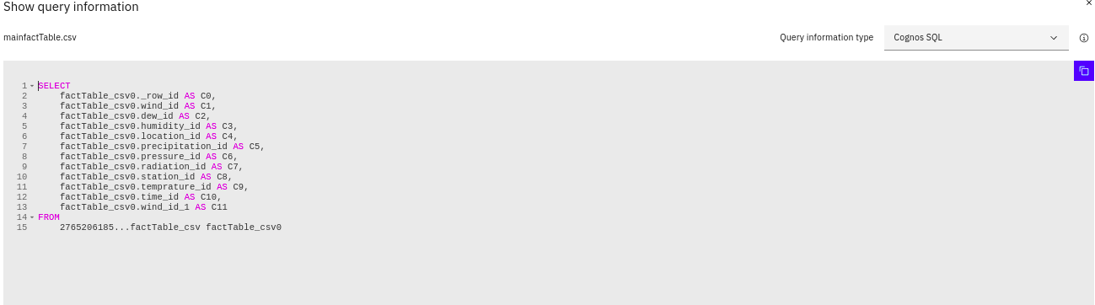

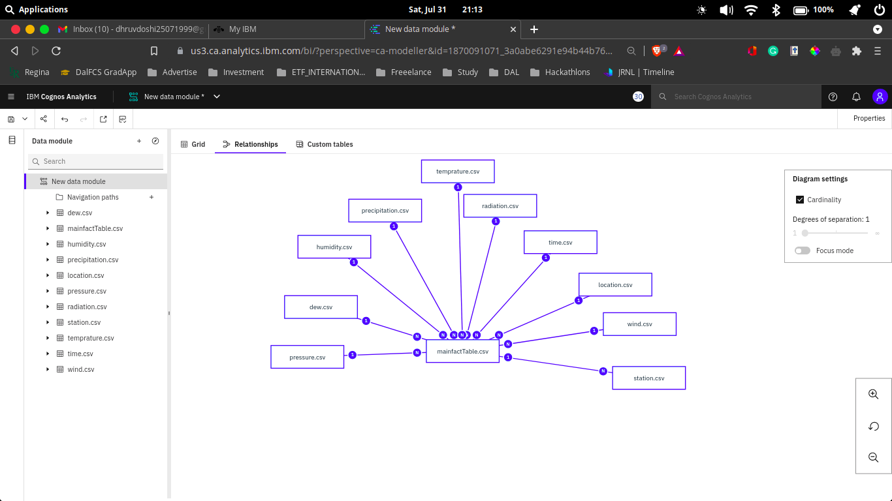

STAR SCHEMA

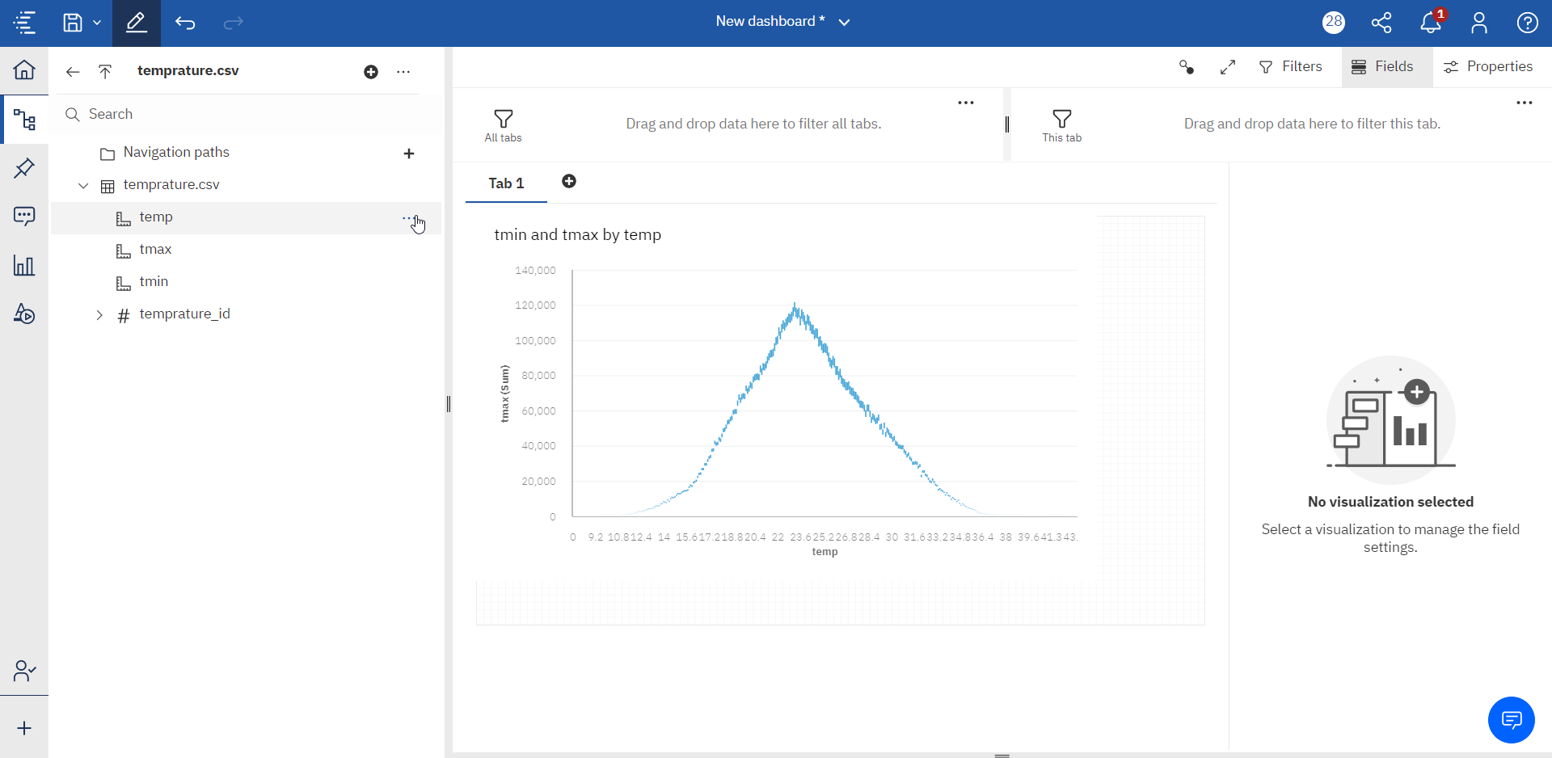

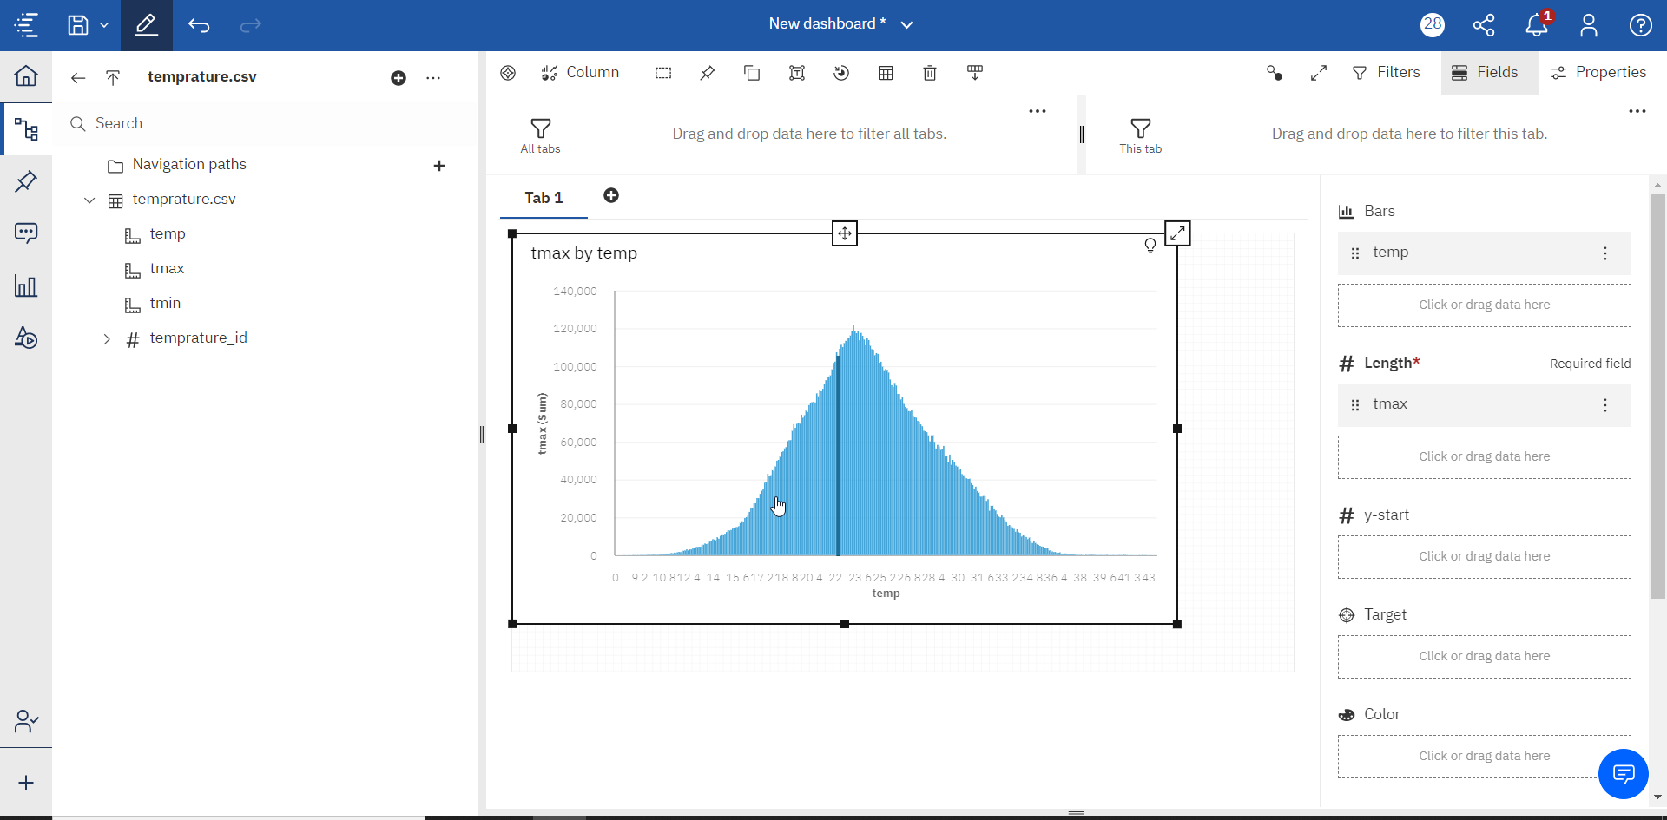

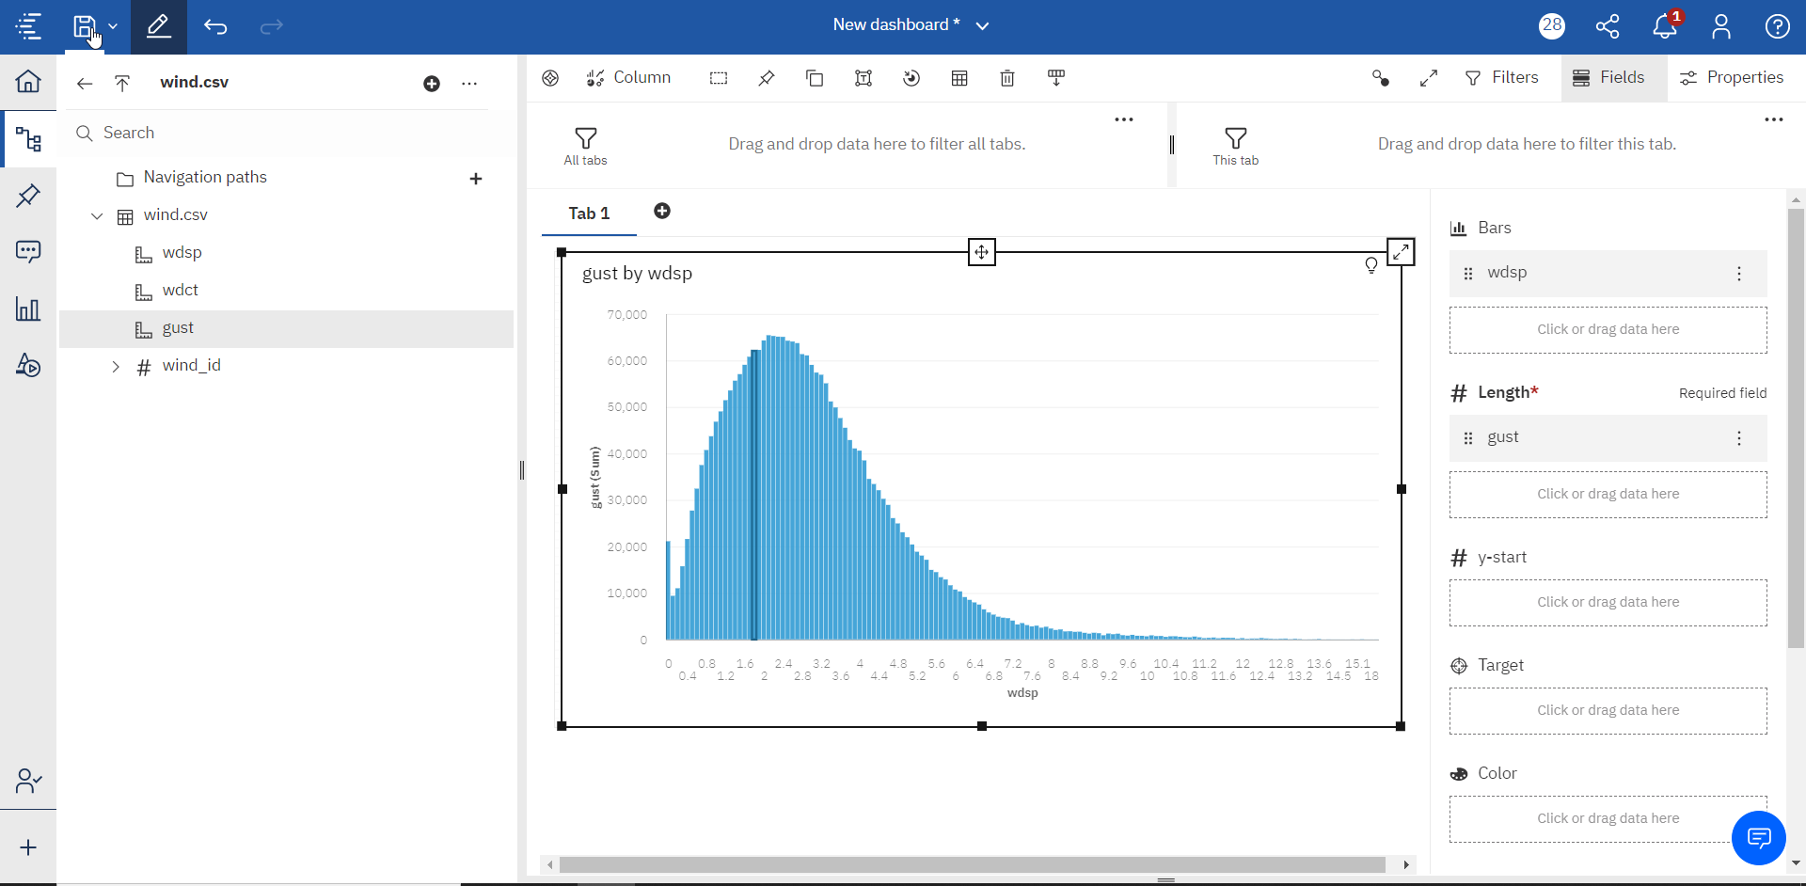

CODE:

SELECT
factTable_csv0._row_id AS C0,
factTable_csv0.wind_id AS C1,
factTable_csv0.dew_id AS C2,
factTable_csv0.humidity_id AS C3,
factTable_csv0.location_id AS C4,
factTable_csv0.precipitation_id AS C5,
factTable_csv0.pressure_id AS C6,
factTable_csv0.radiation_id AS C7,
factTable_csv0.station_id AS C8,
factTable_csv0.temprature_id AS C9,
factTable_csv0.time_id AS C10,
factTable_csv0.wind_id_1 AS C11
FROM
2765206185...factTable_csv factTable_csv0

PART-B

SENTIMENT ANALYSIS

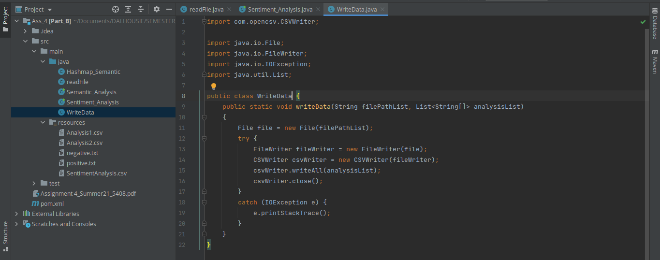

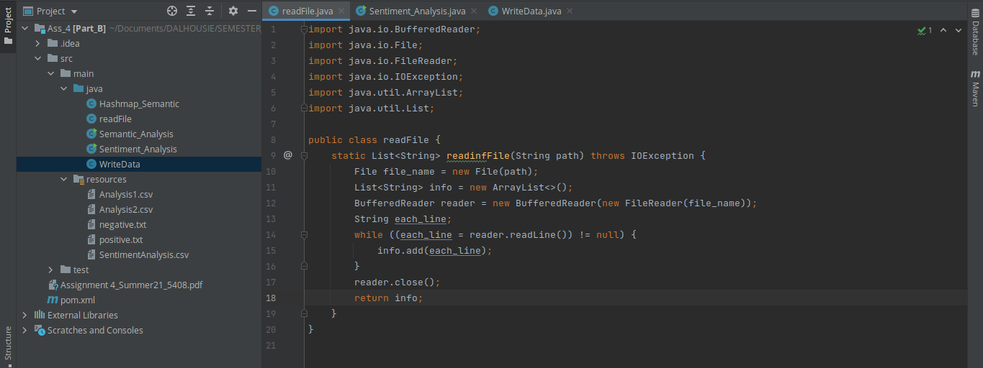

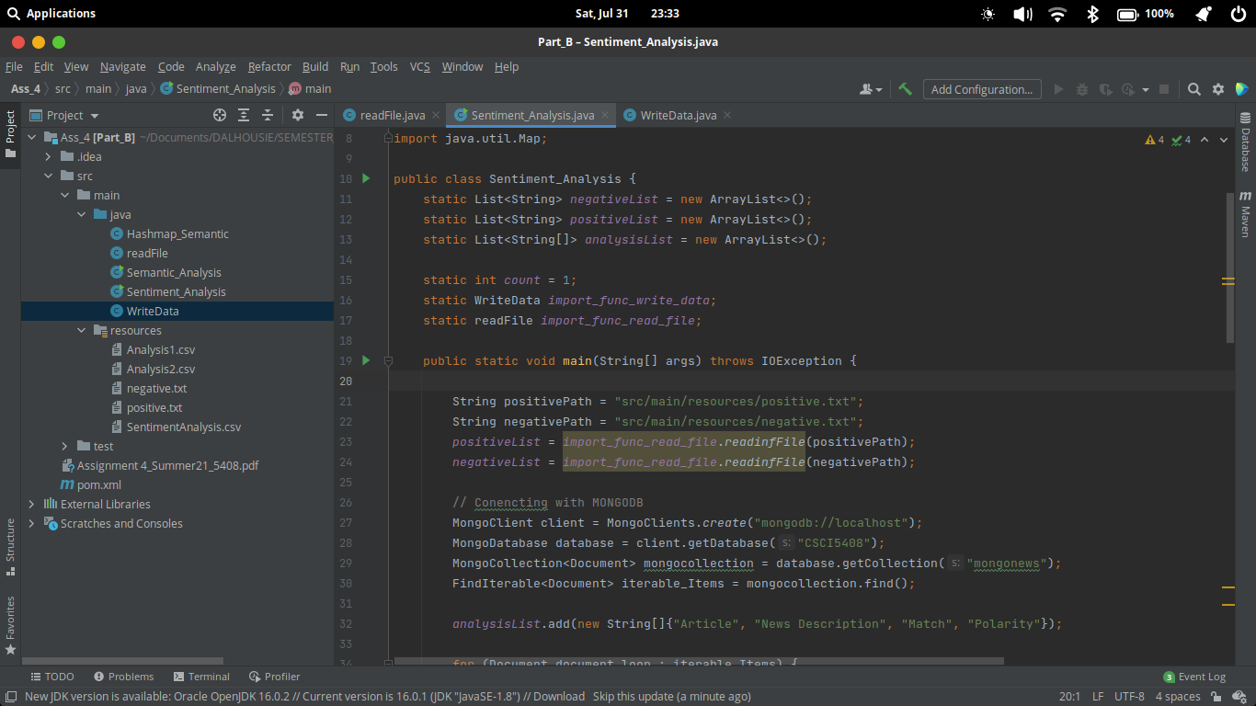

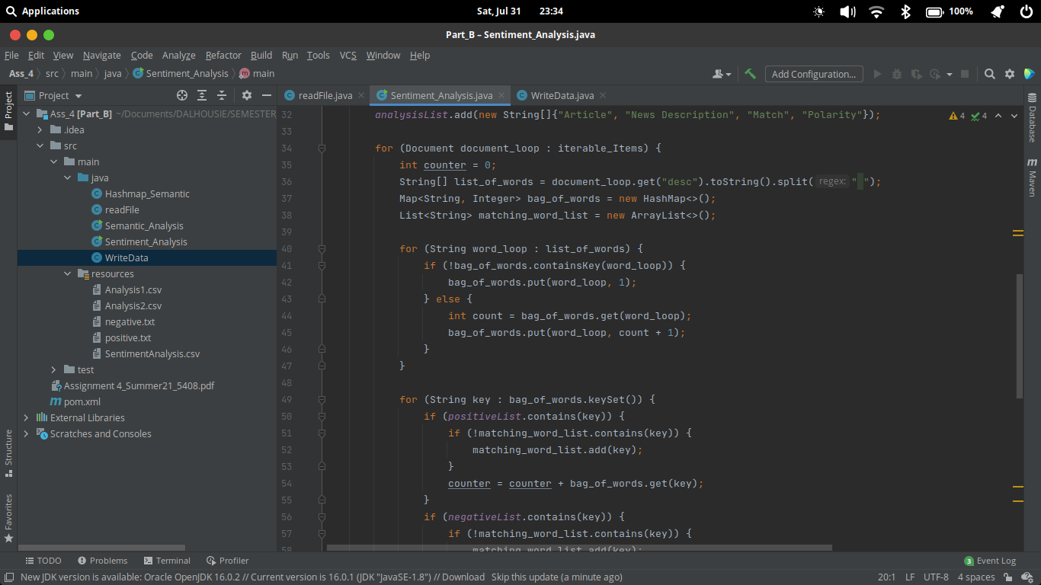

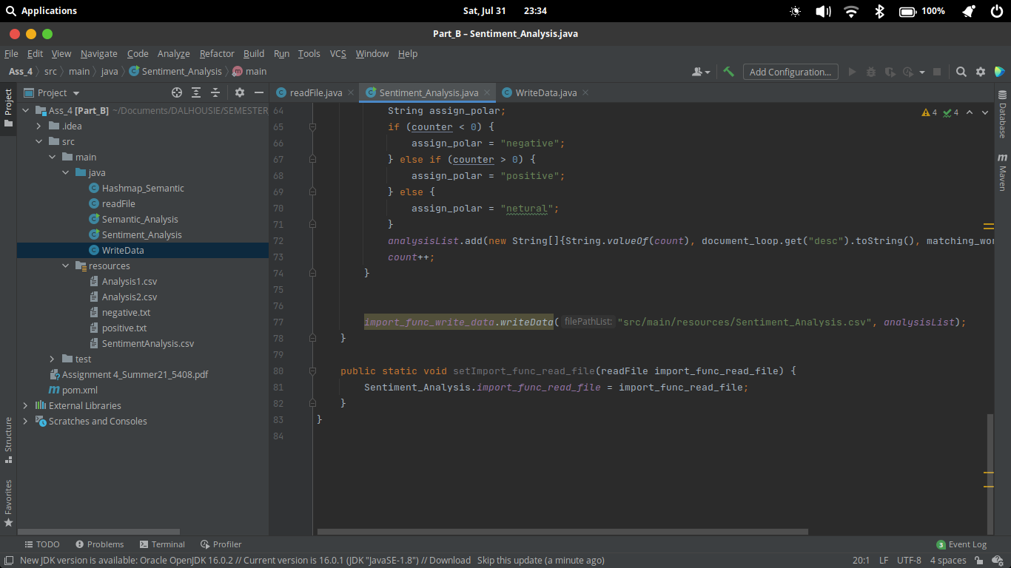

CODE

import com.mongodb.client.*;
import org.bson.Document;
import java.io.*;
import java.util.ArrayList;
import java.util.HashMap;
import java.util.List;
import java.util.Map;
public class Sentiment_Analysis {
static List<String> negativeList = new ArrayList<>();
static List<String> positiveList = new ArrayList<>();
static List<String[]> analysisList = new ArrayList<>();
static int count = 1;
static WriteData import_func_write_data;
static readFile import_func_read_file;
public static void main(String[] args) throws IOException {
String positivePath = "src/main/resources/positive.txt";
String negativePath = "src/main/resources/negative.txt";
positiveList = import_func_read_file.readinfFile(positivePath);
negativeList = import_func_read_file.readinfFile(negativePath);
// Conencting with MONGODB
MongoClient client = MongoClients.create("mongodb://localhost");
MongoDatabase database = client.getDatabase("CSCI5408");
MongoCollection<Document> mongocollection = database.getCollection("mongonews");
FindIterable<Document> iterable_Items = mongocollection.find();
analysisList.add(new String[]{"Article", "News Description", "Match", "Polarity"});
for (Document document_loop : iterable_Items) {
int counter = 0;
String[] list_of_words = document_loop.get("desc").toString().split(" ");
Map<String, Integer> bag_of_words = new HashMap<>();
List<String> matching_word_list = new ArrayList<>();
for (String word_loop : list_of_words) {
if (!bag_of_words.containsKey(word_loop)) {
bag_of_words.put(word_loop, 1);
} else {
int count = bag_of_words.get(word_loop);
bag_of_words.put(word_loop, count + 1);
}
}
for (String key : bag_of_words.keySet()) {
if (positiveList.contains(key)) {
if (!matching_word_list.contains(key)) {
matching_word_list.add(key);
}
counter = counter + bag_of_words.get(key);
}
if (negativeList.contains(key)) {
if (!matching_word_list.contains(key)) {
matching_word_list.add(key);
}
counter = counter - bag_of_words.get(key);
}
}
String assign_polar;
if (counter < 0) {
assign_polar = "negative";
} else if (counter > 0) {
assign_polar = "positive";
} else {
assign_polar = "netural";
}
analysisList.add(new String[]{String.valueOf(count), document_loop.get("desc").toString(), matching_word_list.toString(), assign_polar});
count++;
}
import_func_write_data.writeData("src/main/resources/Sentiment_Analysis.csv", analysisList);
}
public static void setImport_func_read_file(readFile import_func_read_file) {
Sentiment_Analysis.import_func_read_file = import_func_read_file;
}
}

READFILE FUNCTION

import java.io.BufferedReader;
import java.io.File;
import java.io.FileReader;
import java.io.IOException;
import java.util.ArrayList;
import java.util.List;
public class readFile {
static List<String> readinfFile(String path) throws IOException {
File file_name = new File(path);
List<String> info = new ArrayList<>();
BufferedReader reader = new BufferedReader(new FileReader(file_name));
String each_line;
while ((each_line = reader.readLine()) != null) {
info.add(each_line);
}
reader.close();
return info;
}
}

WRITE DATA FUNCTION

import com.opencsv.CSVWriter;
import java.io.File;
import java.io.FileWriter;
import java.io.IOException;
import java.util.List;
public class WriteData {
public static void writeData(String filePathList, List<String[]> analysisList)
{
File file = new File(filePathList);
try {
FileWriter fileWriter = new FileWriter(file);
CSVWriter csvWriter = new CSVWriter(fileWriter);
csvWriter.writeAll(analysisList);
csvWriter.close();
}
catch (IOException e) {
e.printStackTrace();
}
}
}

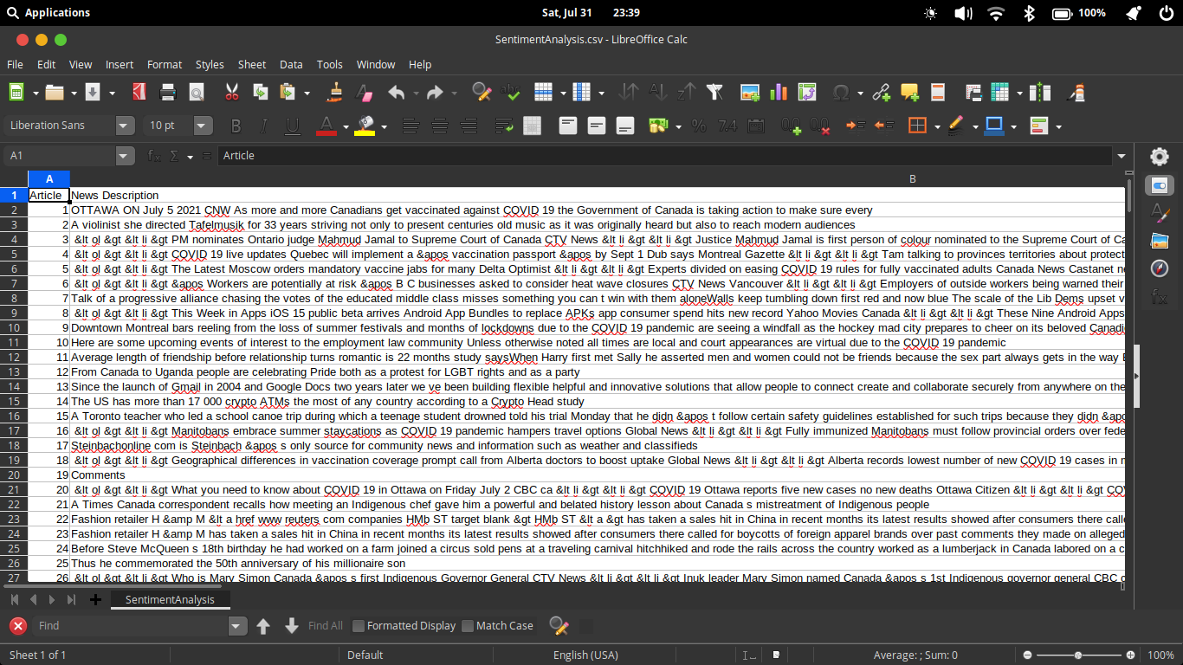
PART – C
SEMANTIC ANALYSIS

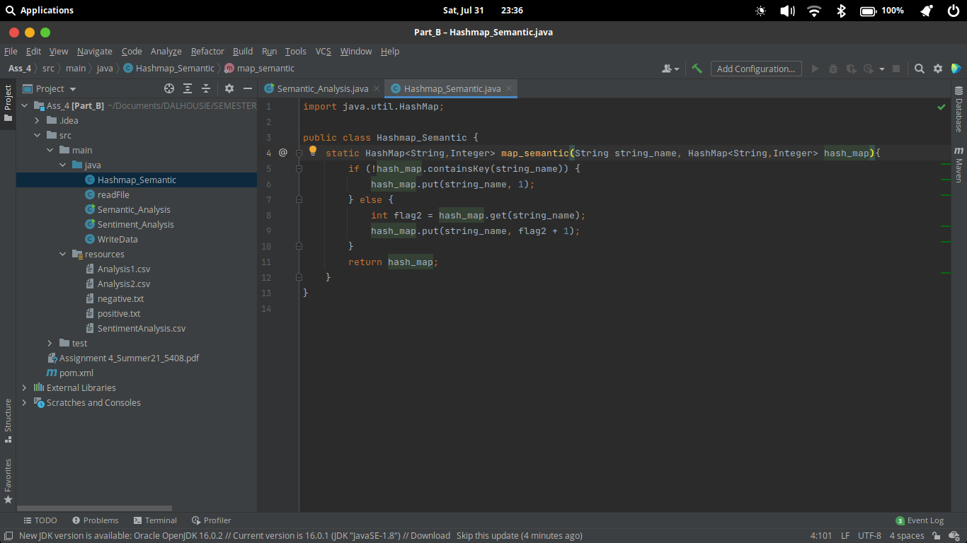
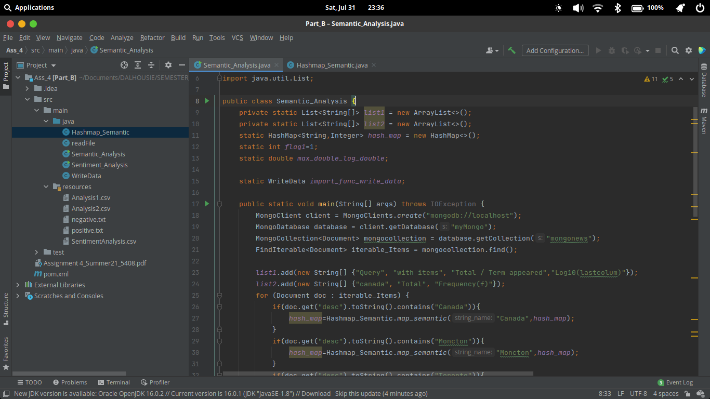
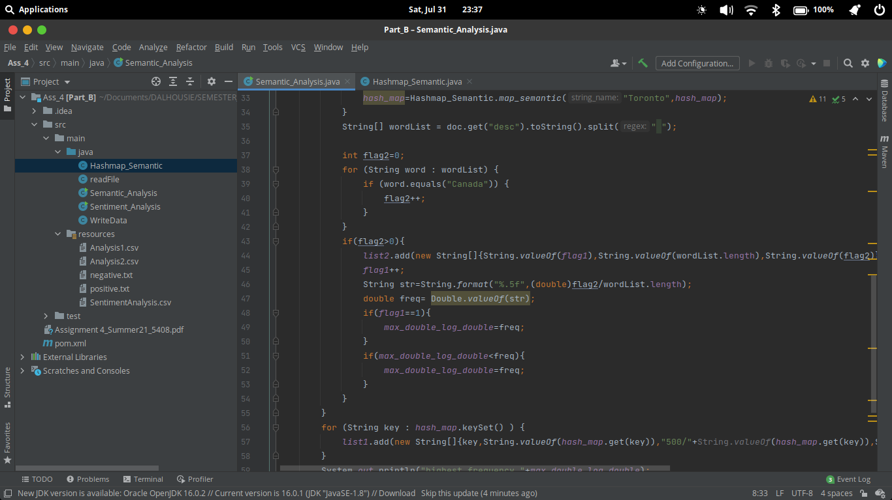

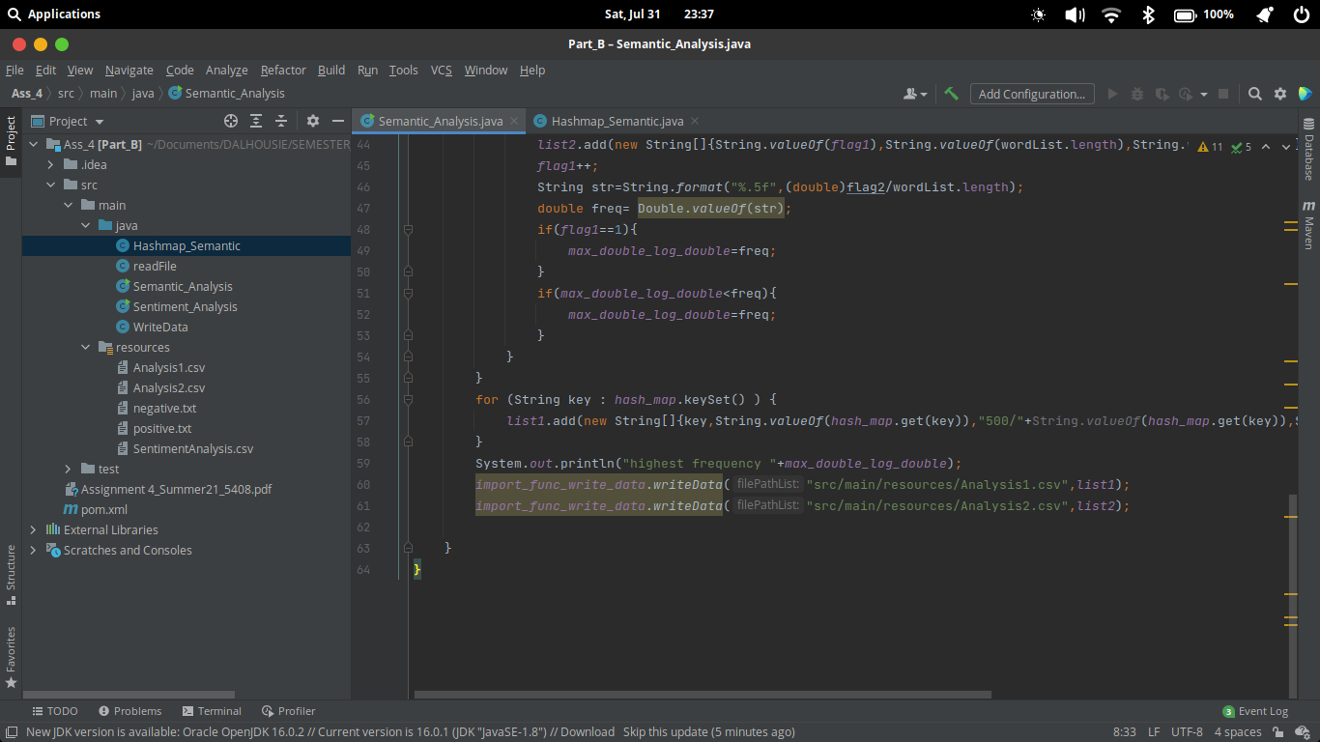

CODE FILES

import com.mongodb.client.*;
import org.bson.Document;
import java.io.IOException;
import java.util.ArrayList;
import java.util.HashMap;
import java.util.List;
public class Semantic_Analysis {
private static List<String[]> list1 = new ArrayList<>();
private static List<String[]> list2 = new ArrayList<>();
static HashMap<String,Integer> hash_map = new HashMap<>();
static int flag1=1;
static double max_double_log_double;
static WriteData import_func_write_data;
public static void main(String[] args) throws IOException {
MongoClient client = MongoClients.create("mongodb://localhost");
MongoDatabase database = client.getDatabase("myMongo");
MongoCollection<Document> mongocollection = database.getCollection("mongonews");
FindIterable<Document> iterable_Items = mongocollection.find();
list1.add(new String[] {"Query", "with items", "Total / Term appeared","Log10(lastcolum)"});
list2.add(new String[] {"canada", "Total", "Frequency(f)"});
for (Document doc : iterable_Items) {
if(doc.get("desc").toString().contains("Canada")){
hash_map=Hashmap_Semantic.map_semantic("Canada",hash_map);
}
if(doc.get("desc").toString().contains("Moncton")){
hash_map=Hashmap_Semantic.map_semantic("Moncton",hash_map);
}
if(doc.get("desc").toString().contains("Toronto")){
hash_map=Hashmap_Semantic.map_semantic("Toronto",hash_map);
}
String[] wordList = doc.get("desc").toString().split(" ");
int flag2=0;
for (String word : wordList) {
if (word.equals("Canada")) {
flag2++;
}
}
if(flag2>0){
list2.add(new String[]{String.valueOf(flag1),String.valueOf(wordList.length),String.valueOf(flag2)});
flag1++;
String str=String.format("%.5f",(double)flag2/wordList.length);
double freq= Double.valueOf(str);
if(flag1==1){
max_double_log_double=freq;
}
if(max_double_log_double<freq){
max_double_log_double=freq;
}
}
}
for (String key : hash_map.keySet() ) {
list1.add(new String[]{key,String.valueOf(hash_map.get(key)),"500/"+String.valueOf(hash_map.get(key)),String.valueOf(Math.log10(500/hash_map.get(key)))});
}
System.out.println("highest frequency "+max_double_log_double);
import_func_write_data.writeData("src/main/resources/Analysis1.csv",list1);
import_func_write_data.writeData("src/main/resources/Analysis2.csv",list2);
}
}

HASHMAP SEMANTIC

import java.util.HashMap;
public class Hashmap_Semantic {
static HashMap<String,Integer> map_semantic(String string_name, HashMap<String,Integer> hash_map){
if (!hash_map.containsKey(string_name)) {
hash_map.put(string_name, 1);
} else {
int flag2 = hash_map.get(string_name);
hash_map.put(string_name, flag2 + 1);
}
return hash_map;
}
}

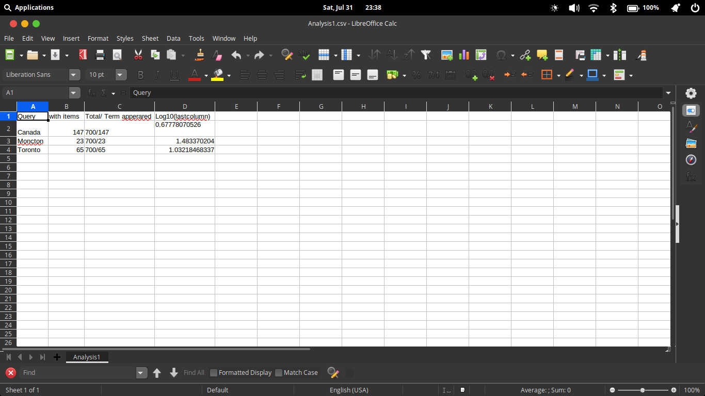
0
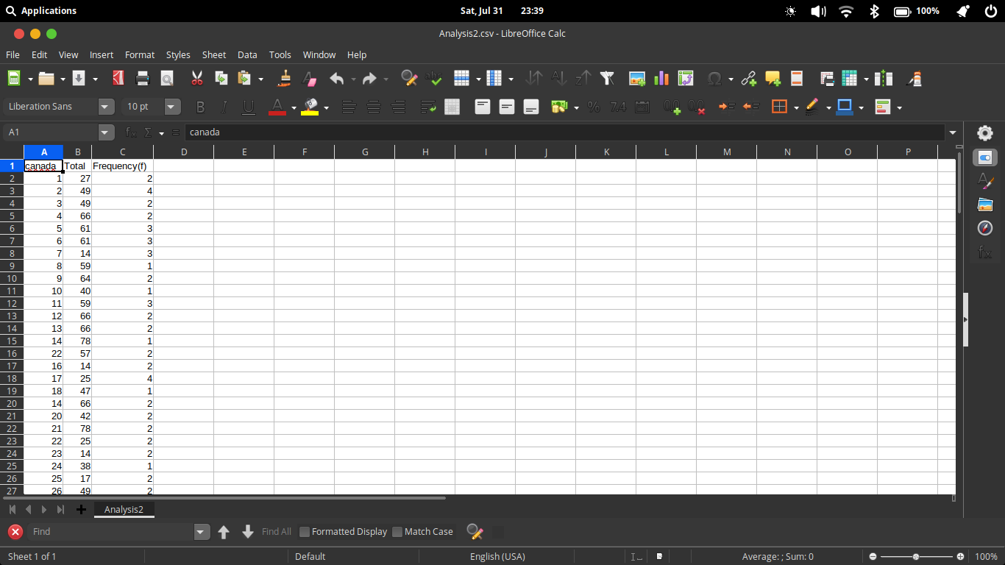

REFERENCES:

[1] “IBM Cognos Analytics,” IBM Cognos Analytics, 2020. [Online]. Available: https://www.ibm.com/ca-en/products/cognos-analytics. [Accessed: 01-Aug-2021]

[2] “IBM Docs,” Ibm.com, 03-Mar-2021. [Online]. Available: https://www.ibm.com/docs/en/cognos-analytics/10.2.2?topic=SSEP7J_10.2.2/com.ibm.swg.ba.cognos.wig_cr.10.2.2.doc/c_gtstd_c8_bi.html. [Accessed: 01-Aug-2021]

[3]Wikipedia Contributors, “IBM Cognos Analytics,” Wikipedia, 13-Jul-2021. [Online]. Available: https://en.wikipedia.org/wiki/IBM_Cognos_Analytics. [Accessed: 01-Aug-2021]

[4]“Kaggle: Your Home for Data Science,” Kaggle.com, 2021. [Online]. Available: https://www.kaggle.com/. [Accessed: 01-Aug-2021]

[5] “opencsv –,” Sourceforge.net, 2013. [Online]. Available: http://opencsv.sourceforge.net/. [Accessed: 01-Aug-2021]

[6] “Calc | LibreOffice - Free Office Suite - Based on OpenOffice - Compatible with Microsoft,” Libreoffice.org, 2021. [Online]. Available: https://www.libreoffice.org/discover/calc/. [Accessed: 01-Aug-2021]

